**Bahria University,**

**Karachi Campus**



**LAB EXPERIMENT NO.**

**13**

**LIST OF TASKS**

|  |  |
| --- | --- |
| TASK NO | OBJECTIVE |
|  | MONGO DB- CRUD OPERATIONS |
| **01** | **Create a database of a company which will hold employee info(_id,name,designation,salary,department) and department info(_id,name), insert 5 records on** |
| **02** | **Increase employee salary to 10% if salary =10000** |
| **03** | **View all records updated** |
| 04 | Delete records from department where department id is 5. |

**Submitted On:**

**14 – 06 - 2023**

**(Date: DD/MM/YYYY)**

**Task No. 1:** **Create a database of a company which will hold employee info(_id,name,designation,salary,department) and department info(_id,name), insert 5 records on each table.**

**Solution:**

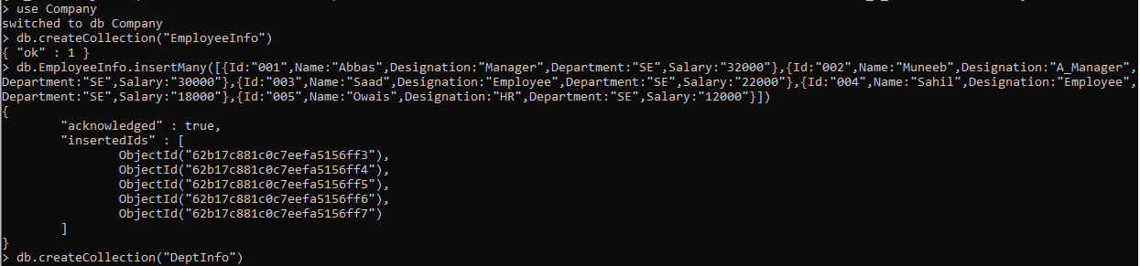

**Task No. 2:** Increase employee salary to 10% if salary =10000

**Solution:**

**Task No. 3:** View all records updated.

**Solution:**

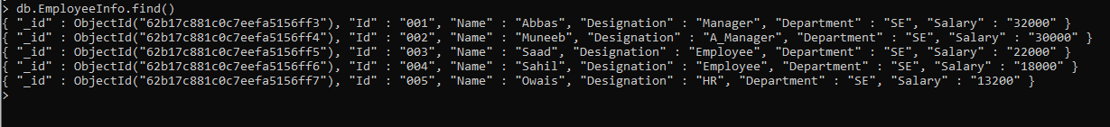

**Task No. 4:** Delete records from department where department id is 5.

**Solution:**

